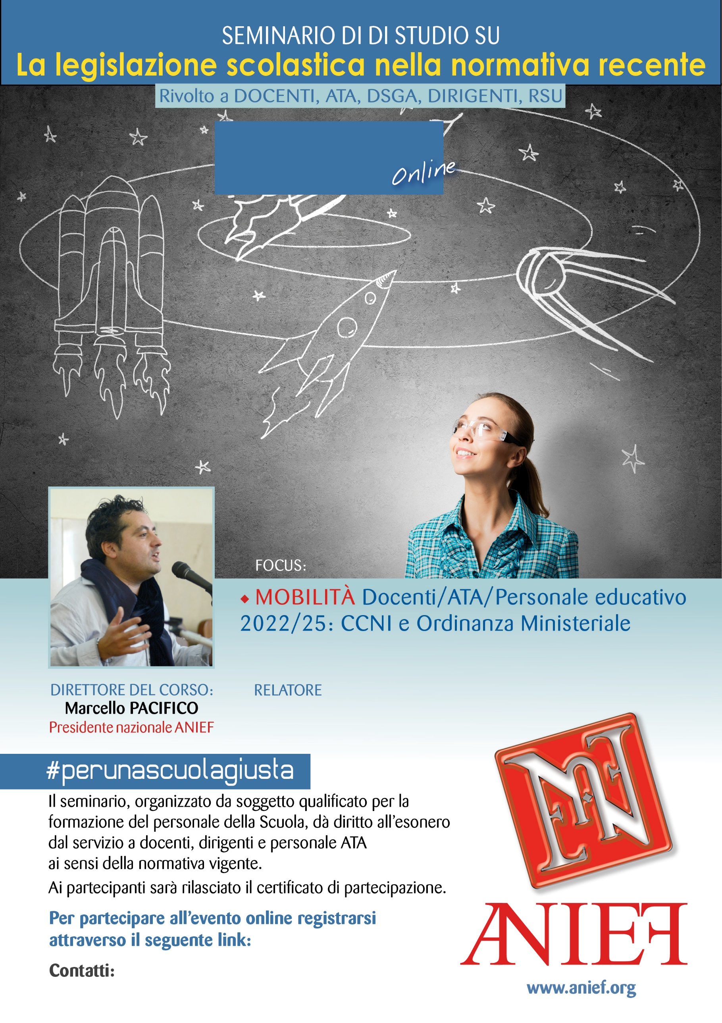

LINK DIRETTA: <https://anief.org/as/ETHS>

catanzaro@anief.net

LEONIDA BIANCHIMANO

CALABRIA - CATANZARO

07/03/2022 ORE 08:00 – 11:00